Dart Airplane
Written Instructions

Materials:
- 1 sheet of standard 8.5" x 11" paper (letter-sized)

Instructions:
- Start with a Sheet of Paper: Place the paper flat on a surface in portrait orientation, with the shorter sides at the top and bottom and the longer sides on the left and right.
- Fold the Paper in Half: Take the left edge of the paper and fold it across to the right edge. Crease the fold sharply, then unfold the paper. You should now have a crease down the center of the paper.
- Fold the Top Corners to the Center Crease: Take the top left corner and fold it in so that it lines up with the center crease. Do the same with the top right corner. This will create a triangle shape at the top of the paper.
- Fold the Top Edges to the Center Crease: Follow the top point of the triangle down along its left side until you come to the end of the left triangle. Take that point and fold it towards the center of the paper on the vertical crease made in Step 2. Repeat this step with the right triangle.
- Fold the Paper in Half: Fold the paper in half along the original center crease, with all the folds on the outside.
- Create the Wings: Orient the plane so the narrow, pointed nose side is to your left and the original crease is at the bottom. Take the top edge and fold it down to meet the original crease. Ensure the top edge is flush with the bottom crease, then crease this fold in place. Flip the airplane over and repeat on the other side to make the second wing.
- Adjust and Finish: To finish, hold the original crease and open up the wings slightly to adjust the plane’s shape for symmetry. If needed, you can tweak the wings for better flight performance.
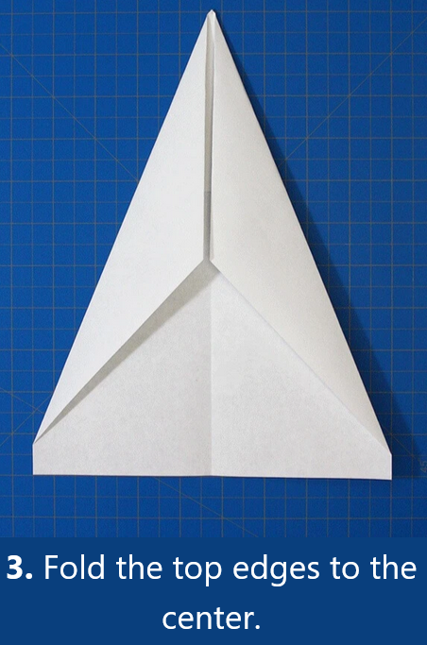
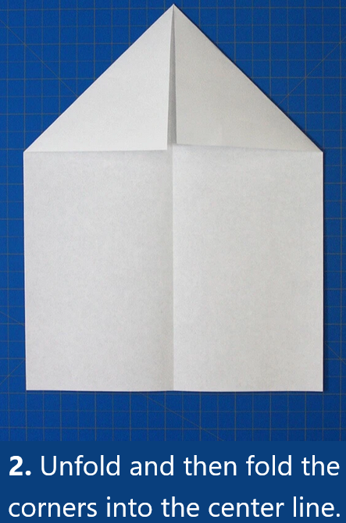
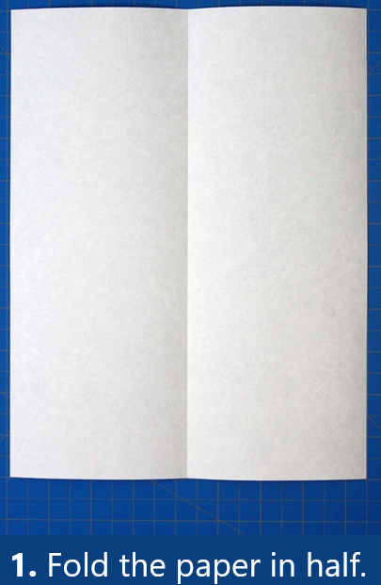
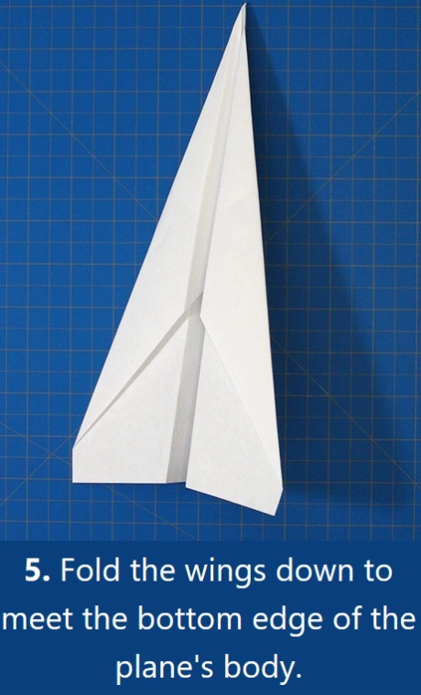
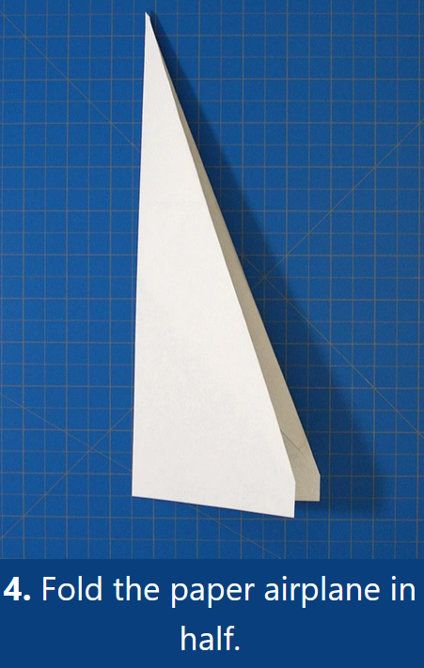
Dart Airplane
Virtual Instructions

